Assignment 1
Practical Questions
---1. Create a Java Application and write a Program that displays “Hello World” on the
Screen.

---2. Write a Program that displays your name on screen within double quotes in the
previously created project and set it as the main class.

---3. Write a Program that accepts 2 numbers and display their sum, product, difference,
and quotient of the two numbers and execute it without setting it as the main class.

---4. Write a Program that accepts a String by your name and display it on the screen.

---5. Write a Program that accepts a float variable by radius and display the area and circumference.

---6. Write a Program that accepts width and height of a Rectangle and display its area and perimeter
.
7. Write a Program that displays a box, an oval, an arrow and a diamond.

---8. Write a Program that accepts principle, rate and time and display simple and compound interest.

---9. Write a Program that accepts and displays your name, address and phone on the screen.

---10. Write a Program that accepts a float variable called centigrade and convert it to Fahrenheit.

Assignment 2
Practical Questions
- ---Write a Program to accepts a character and print whether it is uppercase, lowercase or special character.

- ---Write a Program to accepts a character and print whether it is uppercase, lowercase or special character without using logical operators.

3. Write a Program that accepts an integer and display whether it is a single digit, two digit,
three digits or more than three digits.
---4. Write a Program to accepts a character and print whether it is a vowel or not.
---5. Write a program to print even numbers from 100 to 200.
---6. Write a program to print multiples of 3 from 300 to 100.
---7. Write a program to print sum and average of multiples of 5 from 500 to 600.
---8. Write a program to accept a number and print its table.
---9. Write a program to accept a number and print its reverse multiplication table.
---10. Write a program to accept a number and print whether it is prime or not.
--11. Write a program to print prime numbers from 100 to 200.
12. Write a program to print fibonacci series of 20 elements.

Assignment 4
Practical Questions
1. Write a program that accepts String with an RGB value and print parts of red, green and blue.

2. Write a program that accepts a String with “Betty got a bit of bitter better butter” and perform the
following operations:
a. Print all the occurrences (index) of “b” and “t” in the string.
b. Print each word along with its length in a new line.
c. Print all the words that start with “b” in the string.

3. Write a program that accept a string and check for following:
a. The string should have at least 3 characters.
b. The string should not have any special characters or digits except alphabets.
If any of the condition does not matches appropriate error message should be displayed.

4. Write a program that accept a string and check for following:
a. The string should have only 5 characters.
b. The string should not have any special characters or alphabets except digits.
If any of the condition does not matches appropriate error message should be displayed.

5. Write a program that accepts a string and check for following:
a. The string should have at least 6 characters.
b. The string should not have any special characters except @.
If any of the condition does not matches appropriate error message should be displayed.

6. Write a program that accepts an array by 10 names and display all names that start with “A”.

7. Write a program that accepts an array by 10 names and display all names that end with “h”.

8. Write a program that accepts an array by 10 names and display all names that contain “he”.

9. Write a program that accepts an array by 10 numbers and display them in ascending order.

10. Write a program that accepts an array by 10 numbers and display their sum and average.

11. Write a program that accepts a 2D array of 4 by 5 by numbers and display the sum of all the rows,
columns and the entire matrix. All these details should be displayed in tabular format.

12. Write a program that accepts a number as command line argument and display its square. If argument
contains more than 1 number proper error message should be displayed.

---13. Write a program that accepts a number as command line argument and display its table.

14. Write a program that accepts a 5 numbers as command line argument and display their sum, average
and also display them in ascending order.

15. Create a matrix that contains sales of 4 products for 4 regions and perform the following operations
a. Total sales of products for region-wise
b. Total sales of products product-wise
c. Highest and lowest selling products
d. Total sales made by the company

16. Create 2 matrixes of 4 by 4, accept them and display their product.

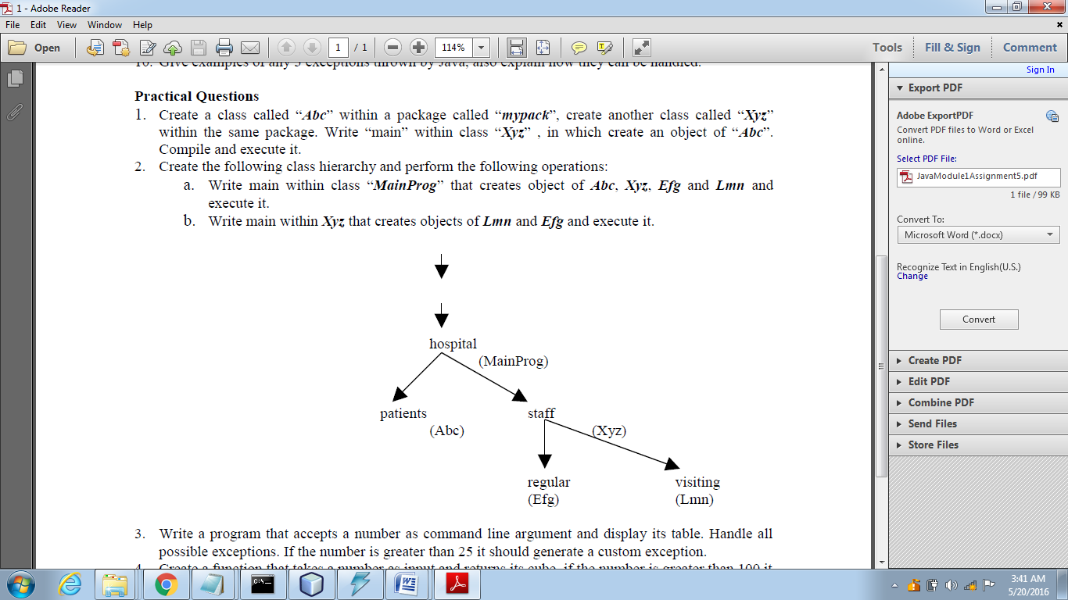
3. Write a program that accepts a number as command line argument and display its table. Handle all
possible exceptions. If the number is greater than 25 it should generate a custom exception.
4. Create a function that takes a number as input and returns its cube, if the number is greater than 100 it
generates NoCubeException. Write a program that accepts a number as command line argument and
print its cube using the function created.
5. In both the above programs try to use finally.

